Experiment:2 Date:21/07/2026

8-Queens Problem Using Backtracking Algorithm

AIM:
To develop a Python program to solve the 8-Queens Problem using the Backtracking Algorithm by placing eight queens on a chessboard such that no two queens attack each other horizontally, vertically, or diagonally.

Algorithm (Backtracking):
- Read the number of queens (N) from the user.
- Create an N × N chessboard initialized with zeros.
- Start placing queens from the first column.
- Check whether the current position is safe (no queen in the same row, upper diagonal, or lower diagonal).
- If the position is safe, place the queen and move to the next column.
- If no safe position is found, backtrack by removing the previously placed queen and try another position.
- Repeat the process until all queens are placed successfully.
- Display the final chessboard configuration.

PROGRAM:
def is_safe(board, row, col, n):
for i in range(col):
if board[row][i] == 1:
return False
i, j = row, col
while i >= 0 and j >= 0:
if board[i][j] == 1:
return False
i -= 1
j -= 1
i, j = row, col
while i < n and j >= 0:
if board[i][j] == 1:
return False
i += 1
j -= 1
return True
def solve(board, col, n):
if col == n:
return True
for i in range(n):
if is_safe(board, i, col, n):
board[i][col] = 1
if solve(board, col + 1, n):
return True
board[i][col] = 0
return False
n = int(input("Enter number of Queens: "))
board = [[0] * n for _ in range(n)]
if solve(board, 0, n):
print("\nSolution Found\n")
step = 1
for row in board:
print("Step", step)
print(*row)
step += 1
else:
print("No Solution")

OUTPUT:
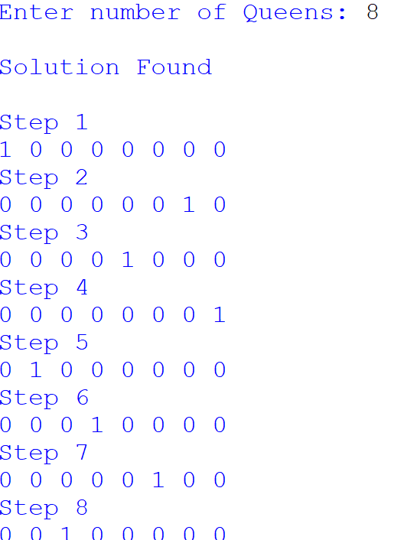

RESULTS:
Thus, the 8-Queens Problem was solved successfully using the Backtracking Algorithm, and a valid arrangement of eight queens was obtained without any conflicts.

